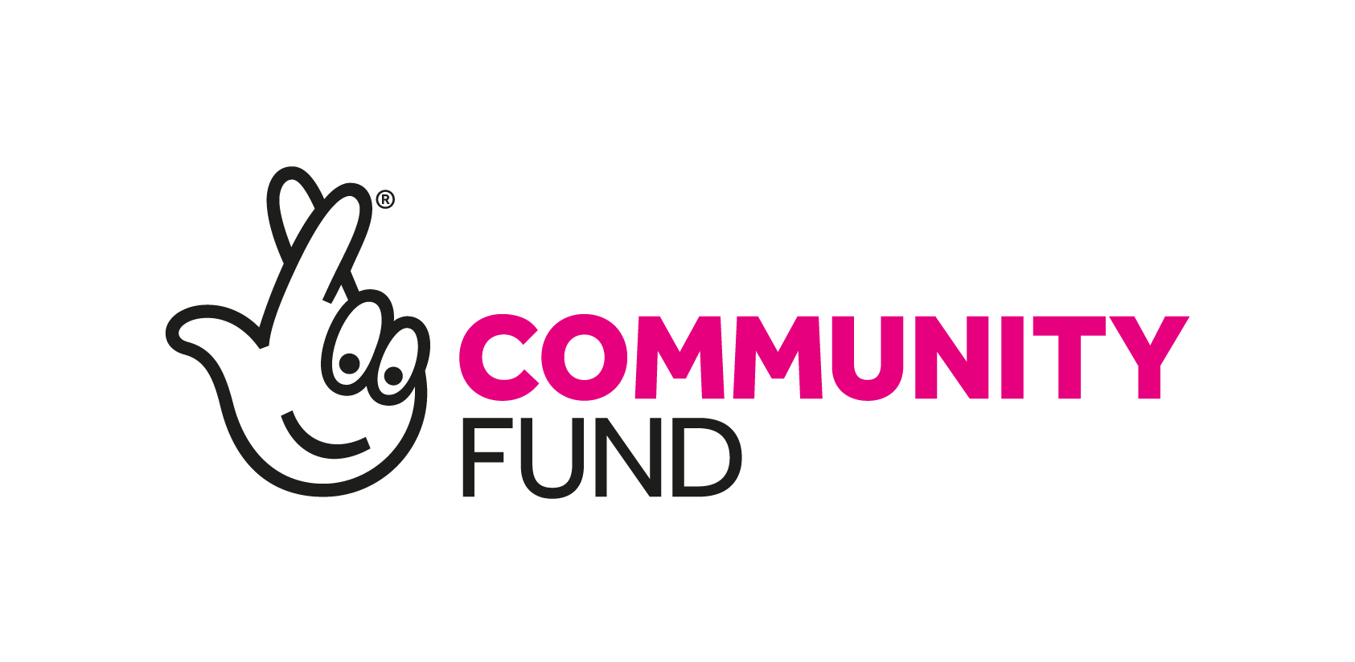Person Specification

Wiltshire Autism Hub - Development/Outreach Worker

Essential:

Values:
- Commitment to service user-led community development work.
- Understanding of the Social Model of Disability and empowerment.
- Commitment to working in an anti-discriminatory way in accordance with the Network’s Policy on Equal Opportunities.
- Commitment and understanding of working in person-centred way

Knowledge and Skills:
- Direct knowledge and experience of issues faced by people with Autism
- Knowledge of the benefits system
- Ability to be a mentor and an enabler
- Ability to support and enable people to voice their issues
- Resilience and ‘can do’ attitude
- Ability to think creatively to solve problems and challenges
- Good communication skills, face to face, by phone, in writing and through video conferencing
- Research and report writing skills
- Ability to work independently within accountability requirements to line management
- Ability to organise and prioritise own caseload
- Ability to use computer technology, in particular e-mails, word-processing and accessing database information
- Ability to travel independently of public transport within Wiltshire

Desirable:

- Understanding of the role of user-controlled organisations.
- Knowledge and understanding of the structures of Health, Social Care and Community services.
- Experience within at least one of the following areas: Physical &/or Sensory impairment, Mental health Issues, long term conditions.

